AUSTRALIAN MEDICAL ACUPUNCTURE COLLEGE (AMAC)
Proudly presents
Understanding Acupuncture, Myofascial Pain and Myofascial Meridian Concepts through Neuroanatomy-Applications for Musculoskeletal Disorders.
With International Guest Speaker
Dr Peter Dorsher
Mayo Clinic Jacksonville Florida USA
And Local Speakers
Dr Chris Chin
State president AMAC WA
Dr Katrina Watson
Federal President AMAC
Dr Christina Teng
Medical Oncologist and PHD candidate
Dr Bill Meyers
Chair of Examination AMAC
Saturday 5th of November 2022
Online activity via ZOOM
NO Cat 1 points are available for this activity
(but you can apply for points for self-learning hours)

This invitation to attend is limited to Medical Acupuncturists, Medical Practitioners and Medical Dentists

PROGRAM
AEDST: Australian Eastern Daylight Saving Time (GMT + 11)
AWST: Australian Western Standard Time (GMT +8)
AEDST AWST
9.30 am 6.30 am ZOOM open
10 am 7 am Welcome by Dr Katrina Watson(AMAC), Dr Chin Chan(ICMART)
10.15 am 7.15 am Dr Peter Dorsher: How Much Anatomy did the TCM Founders know?
Based on Chinesiche Medizin article on how neuroanatomic acupuncture can explain some paradox in Nei-Jing including details of the extensive anatomic knowledge of the TCM founders
10.40 7.40 Dr Peter Dorsher: Evidence for the mechanism of Trigger Points
Anatomic, physiological and clinical data accumulated to demonstrate that myofascial trigger points are a neurogenic phenomenon and not a muscular fascial one; including data from the earliest myofascial pain syndrome researchers.
11.05 8.05 Dr Peter Dorsher: An APP to illustrate Myofascial Trigger Points.
APP for iPad 3D illustrations of Myofascial Trigger points and their anatomical, physiological and clinical correspondences with referred pain patterns which may be used to validate primary acupuncture channels
11.30 8.30 Dr Peter Dorsher: Data on the Neurophysiology of Acupuncture.
Neurological rather than fascial signalling in acupuncture mechanisms in analgesic, anti- inflammatory and visceral effects occurring through neuromodulation. Current data.
12.15pm 9.15 Dr Peter Dorsher:
Practical Application of Neuroanatomy to Acupuncture Treatment of Shoulder and Lower Back Pain.
How to combine neuroanatomic and traditional acupuncture concepts to treat joint and radicular pain problems in the shoulder and back.

AEDST: Australian Eastern Daylight Saving Time (GMT + 11)
AWST: Australian Western Standard Time (GMT + 8)

AEDST AWST
1.00 pm 10.00 Dr Chris Chin:
Musculoskeletal Impingement Theory in the application of acupuncture for Head and Neck Pain
Musculoskeletal impingement as a precipitating factor in the development and perpetuation of active myofascial trigger points/ashi points and referral pain patterns down acupuncture meridians of head and neck.
1.45 pm 10.45 Dr Katrina Watson:
Laser acupuncture for a patient with radial nerve palsy from post operative arterial thrombosis
2.00 pm 11.00 Dr Christina Teng:
Laser Acupuncture treatment of Peripheral Neuropathy in cancer.
A phase 2, randomised, non-comparative trial performed to assess the effect of photo biomodulation to treat chemotherapy-induced peripheral neuropathy.

2.25 pm 11.25 Dr Bill Meyers:
Emerging Evidence in Neuroimmunology for the Medical Acupuncture treatment of Long Covid
Long COVID is a complex condition with a myriad of symptoms that can be partially explained by a disordered immune response, possibly to residual spike protein or other viral particle remnants. Medical
acupuncture can modulate disordered immune response. Let me tell you how...

2.45 pm 11.45 Question Time and Thank you
3.00 pm 12.00 noon Federal AGM
4.00 pm 1.00 pm Finish

REGISTRATION FORM: Understanding Acupuncture, Myofascial Pain and Myofascial Meridian Concepts through Neuroanatomy-Applications for Musculoskeletal Disorders.
AMAC ABN 49 006 101 613
REGISTRATION FEE:
AMAC MEMBERS: AUD $ 165 (incl GST)
AMAC MEMBERS Early Bird: AUD $ 110 (incl GST) BEFORE 14th OCTOBER 2022
NON AMAC MEMBERS: AUD $ 220 (incl GST)
RSVP by closing date 24th October 2022
Cancellation of Booking is Non-Refundable
NAME:__________________________________________
Email:___________________________________________
Mobile Phone:____________________________________
ADDRESS:________________________________________

Payment:
BSB is 086488 Acc. No. is 837915800.
Please state your name with your payment. For payments from outside of Australia please add the Swift code
Swift Code is NATAAU3303M. BSB is 086488 Acc. No. is 837915800.
Foreign exchange and banking charges may apply

REGISTRATION FOR AMAC financial members who wish to attend the AGM ONLY
3:00 pm AEDST (Australian Eastern Daylight Saving Time) 12 noon WAST (Western Australian Standard Time)
NAME:
EMAIL:
MOBILE PHONE
ADDRESS

Please email this page to amacwa2022@gmail.com on the same day as your payment

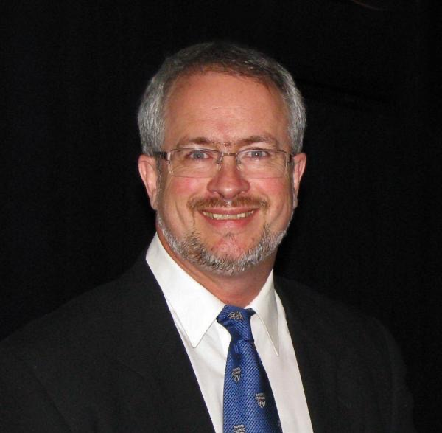
Dr Peter T. Dorsher, MSc Biomedical Engineering, MD
Mayo Clinic, Emeritus and Former Chairperson
Department of Physical Medicine and Rehabilitation
Current Affiliation: East West Integrative Education

Dr. Peter Dorsher has been an AAMA member since completing the UCLA/HMI (Dr Joseph Helms’) training program in 1998. After completing a master’s degree in biomedical engineering at North western University, he pursued a medical degree and trained in Physical Medicine and Rehabilitation at Mayo Clinic Rochester, and subsequently joined the staff there before transferring to its Florida branch, where he practiced for 25 years including serving as chairperson of his department before retiring in 2020.
His primary clinical interests have been in chronic pain syndromes and neurologic disorders. He has 35 years’ experience in treating myofascial pain syndrome, nearly 25 years’ experience using medical acupuncture, and over 15 years’ experience in use of low-level laser therapy for pain conditions. He has presented at over 200 national and international meetings on these topics; has over 80 publications including 42 peer reviewed articles in acupuncture and allopathic journals (including Journal of Pain and Nature Precedings); and has won multiple research awards from the American Academy of Medical Acupuncture.
He is now focusing on research and education, compiling 30 years of data and publication to explore acupuncture’s mechanisms and its fundamental overlaps with the myofascial pain syndrome and myofascial meridian traditions. A trigger point - Classical acupuncture point APP and a hybrid evidence-based acupuncture and myofascial pain educational venture are now in production.

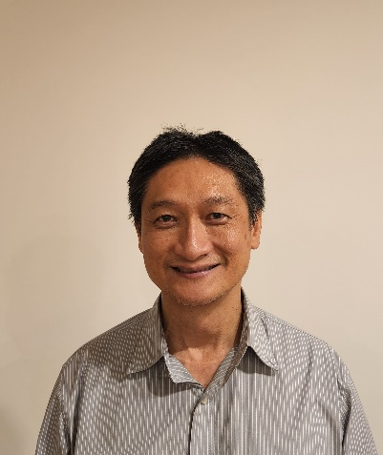
Dr Chris Chin MBBS FAMAC

MB, BS University of Western Australia 1984
Laser Acupuncturist at Cockburn Medical Centre since 1986
Family Medical Program Certificate of Completion 1990
Fellow Australian Medical Acupuncture Society 1987
Fellow Australian medical Acupuncture College 2000
Post Graduate course in Sports Medicine Australia 2000
Presenter ICCWA Falls Prevention Video 2003
Author of Be Your Own Back Guru 7 ways to Beat Back Pain 2008
President of the Western Australian branch of Australian Medical Acupuncture College 2017

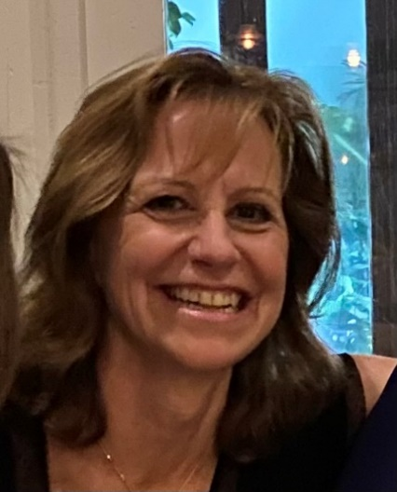
Dr Katrina Watson, MBBS dipObsRACOG FAMAC,
Dr Katrina Watson practises as an integrative medicine GP in Geelong, having studied nutritional medicine, homoeopathy, herbal medicine and holding her fellowship in acupuncture since 1995. She is federal president and Victorian/Tasmanian state president of AMAC.

Dr Christina Teng BMed MMed (Clin Epi) FRACP

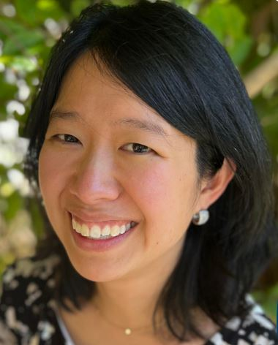
Dr Teng is an experienced Oncologist who completed her internship at Gosford and Wyong Public Hospitals, followed by specialist oncology training at The Kinghorn Cancer Centre, Liverpool, Bankstown and Concord Hospitals.
An award-winning cancer researcher with an interest in cancer survivorship, Dr Teng is completing her PhD studies on the topic of chemotherapy-induced peripheral neuropathy at the University of Sydney. She has published peer-reviewed research on neuropathy symptoms in cancer survivors as well as novel ways of assessment and treatment of chemotherapy-induced peripheral neuropathy.
Dr Teng is a member of the Australasian Gastro-Intestinal Trials Group (AGITG) She also holds professional memberships with Australia new Zealand Gynaecology Oncology Group (ANZGOG) and the Medical Oncology Group of Australia (MOGA).
Dr Teng also practices at the Scientia Clinical Research early phase clinical trials unit in Randwick.

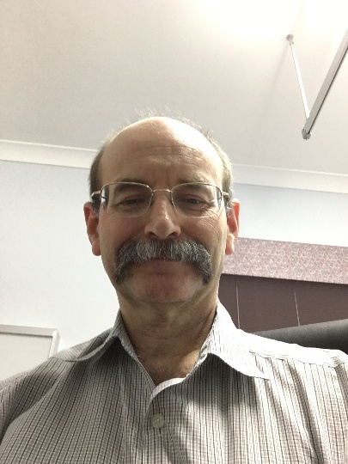
Dr Bill Meyers

ACRRM representative JCCMA
11/03/2014 to present
Examination chair Australian Medical Acupuncture College
08/11/2018 to present

Federal president Australian Medical Acupuncture College
08/11/2013 to 08/11/2016

federal treasurer Australian Medical Acupuncture College
2004 to 08/11/2013

Queensland branch vice president Australian Medical Acupuncture College
28/07/2011 to present

Queensland branch President Australian Medical Acupuncture College
15/07/2006 to 28/07/2011

Queensland branch treasurer Australian Medical Acupuncture College
28/07/2001 to 15/07/2006

